Course Contents

1. Core Java
2. JDBC
3. Hibernate
4. Spring Core
5. Spring MVC
6. Spring REST
7. Spring Boot
8. Spring Data JPA
9. Spring Microservices

Softwares:

1. JDK 1.8
2. Eclipse IDE for Enterprise Developers
3. Database - Derby/MySQL

Java:

Java is platform independent and Object-Oriented programming language.

Platform Independent:

You can run java program on multiple platforms without altering (without recompiling).

Object Oriented Program:

Object oriented program allows you to create real world entities in the applications and make an object communicate with another object to complete any task.

Ex: In banking applications you can have objects like Customer, Employee, Account, Loan and etc.

Object will have 2 things

1. Properties: What object has like name, dob, phone, …
2. Behaviours: What object does like debit(), withdraw(), getInformations(),…

2 Building blocks of any object-oriented language are:

1. Class: It is a blue print/template for an object
2. Object: It is an instance of a class

HelloApp.java

**package** com.org;

**public** **class** HelloApp {

**public** **static** **void** main(String[] args) {

System.***out***.println("Welcome to eclipse");

**int** x = 10;

System.***out***.println("x = "+x); System.***out***.println("x = "+x);

}

}

Fundamentals of Java

* Datatypes
* Operators
* Conditional Statements
* Looping Constructs
* Arrays
* Classes & Objects

Datatypes: It specifies what kind of value a variable can store, there are 8 primitive datatypes in Java

1. byte
2. short
3. int
4. long
5. float
6. double
7. char
8. boolean

byte, short, int & long can store integral values i.e., whole numbers but their size varies

byte - 1 byte: -128 to -1 and 0 to 127  
short - 2 bytes: -32768 to -1 and 0 to 32767  
int - 4 bytes  
long - 8 bytes

int x = 25;  
long y = 35;

float & double can store floating point values float takes 4 bytes & double takes 8 bytes

double a = 20.25;

float b = 20.25f; // since 20.25 is considered as double type you need to explicitly use 20.25f, so that compiler treats the value as float type.

char stores single character its size is 2 bytes

char c = ‘M’;

boolean stores either true/false, its size is 1 byte

boolean b = true;

All the above types belong to primitive datatypes.

Primitive types mean it can store single value/simple values

We have another type in datatypes i.e., derived types which can store objects

Naming Convention

Classnames: Must begin with uppercase & follow camel case

Variables & Methods: Must begin with lowercase & follow camel case

Constructors: Must begin with uppercase & follow camel case

Packages: Must begin with lowercase & use . to separate the package & sub-package

TestDatatypes.java

**package** com.org;

**public** **class** TestDatatypes {

**public** **static** **void** main(String[] args) {

**byte** byteValue = 127;

System.***out***.println("byteValue: "+byteValue);

**float** floatValue = 20.5f;

System.***out***.println("floatValue: "+floatValue);

**boolean** booleanValue = **true**;

System.***out***.println("booleanValue: "+booleanValue);

**char** gender = 'M';

System.***out***.println("gender: "+gender);

gender = 'F';

System.***out***.println("gender: "+gender);

String name = "Alexandar";

System.***out***.println("name: "+name);

}

}

Output:

byteValue: 127

floatValue: 20.5

booleanValue: true

gender: M

gender: F

name: Alexandar

Operators: It is used to perform the operations on the variables like arithmetic operations, logical operations

Some of the operations are:

+, -, *, /, =, <, >, <=, >=, ==, ++, --, &&, ||

TestOperators.java

**package** com.org;

**public** **class** TestOperators {

**public** **static** **void** main(String[] args) {

**double** amount = 25000;

**double** balance = 20000;

**if**(amount <= balance) {

System.***out***.println("Amount can be withdrawn");

balance = balance - amount;

} **else** {

System.***out***.println("Amount exceeds the balance");

}

System.***out***.println("Balance: "+balance);

}

}

Output:

Amount exceeds the balance

Balance: 20000.0

Conditional Statements

Some of the conditional statements

1. if
2. if - else
3. if - else if else if … else
4. switch

TestIfElseIf.java

**package** com.org;

**public** **class** TestIfElseIf {

**public** **static** **void** main(String[] args) {

**int** marks = 60;

**if**(marks >= 70) {

System.***out***.println("FCD");

} **else** **if** (marks >= 60 && marks < 70) {

System.***out***.println("First class");

} **else** **if** (marks >= 50 && marks < 60) {

System.***out***.println("Second class");

} **else** **if** (marks >= 35 && marks < 50) {

System.***out***.println("Pass");

} **else** {

System.***out***.println("Fail");

}

}

}

Output:

First class

Looping constructs

For loop

While loop

Do while loop

TestLoop.java

**package** com.org;

**public** **class** TestLoop {

**public** **static** **void** main(String[] args) {

**for**(**int** i = 1; i <= 10; i++) {

System.***out***.println("i = "+i);

}

System.***out***.println("-------------");

**int** counter = 10; // 0

**while**(counter > 0) { // 0 > 0

System.***out***.println("Counter: "+counter);

counter--;

}

System.***out***.println("--------------");

counter = 10;

**do** {

System.***out***.println("Do-while counter: "+counter);

counter--;

} **while**(counter > 0);

}

}

We can also use arrays and iterate the arrays using loops

Array: It is a container to store multiple values in a single variable

int marks1 = 55, marks2 = 75, ….

int[] marks = {55, 75,….}

TestArrays.java

**package** com.org;

**public** **class** TestMarks {

**public** **static** **void** main(String[] args) {

**int**[] marks = {75, 80, 70};

// array starts from 0th index, it has length property

System.***out***.println("Size: "+marks.length);

**for**(**int** i = 0; i < marks.length; i++) { // i < 3

System.***out***.println("marks: "+marks[i]); // i = 2, marks[2]

}

}

}

Output:

Size: 3

marks: 75

marks: 80

marks: 70

Classes & Objects

Class is blue print of an object or template of an object, it doesn’t take space on the heap

Object is a real-world entity or instance of a class.

What all the things we can write in a class?

1. Variables - properties
2. Methods - behaviours
3. Constructors - like methods but name will be same as class name which is used to initialize the object.

Employee.java

**package** com.org;

**public** **class** Employee {

**int** id;

String name;

**double** salary;

**void** display() {

System.***out***.println("Id = "+id);

System.***out***.println("Name = "+name);

System.***out***.println("Salary = "+salary);

}

}

Note: By default every class will have the default constructor which doesn’t take any parameter, the default constructor is created by the compiler

Note: Default constructor is created only when explicitly no constructors are present in the class

TestEmployee.java

**package** com.org;

**public** **class** TestEmployee {

**public** **static** **void** main(String[] args) {

// creating object of Employee class

// data-type variableName = value;

// int x = 20;

Employee e1 = **new** Employee();

Employee e2 = **new** Employee();

e1.id = 100;

e1.name = "Alex";

e1.salary = 35200.0;

e2.id = 200;

e2.name = "Bruce";

e2.salary = 42000.0;

// invoke display e1.display() & e2.display()

e1.display();

System.***out***.println("--------------------------------");

e2.display();

}

}

Constructors with parameters

StudentConstructor.java

**package** com.org;

**public** **class** StudentConstructor {

**int** rollNo;

String name;

**char** grade;

StudentConstructor(**int** r, String n, **char** g) {

System.***out***.println("StudentConstructor(int, String, char) called");

rollNo = r;

name = n;

grade = g;

}

**void** display() {

System.***out***.println("RollNo = "+rollNo+", Name = "+name+", Grade = "+grade);

}

}

TestStudent.java

**package** com.org;

**public** **class** TestStudent {

**public** **static** **void** main(String[] args) {

StudentConstructor s1 = **new** StudentConstructor(100, "Alex", 'C');

StudentConstructor s2 = **new** StudentConstructor(200, "Bruce", 'A');

s1.display();

System.***out***.println("--------------------");

s2.display();

}

}

Output:

StudentConstructor(int, String, char) called

StudentConstructor(int, String, char) called

RollNo = 100, Name = Alex, Grade = C

--------------------

RollNo = 200, Name = Bruce, Grade = A

Note: In the above example we are avoiding the initialization of properties for every object

Constructor Overloading:

Having more than one constructor’s in the class

Exercise:

1. Create User class with 4 properties
   1. name
   2. age
   3. phone
   4. email
2. Create 4 constructors to initialize the variables
   1. One constructor to initialize name & age
   2. One constructor to initialize name, age, phone
   3. One constructor to initialize name, age, email
   4. One constructor to initialize name, age, phone, email
3. Create a display to show the user properties

Types of variables in Java

We have 3 types of variables

1. Instance Variables: Every object will have separate copies of instance variable
2. Static Variables: All the objects share single copy of static variables, you will use class name to access however you can also use object reference to access the static variables
3. Local Variables/Parameter Variables: It is local to the particular scope.

User.java

**package** com.org;

**public** **class** User {

**int** id;

**static** **int** *counter*;

}

TestVariables.java

**package** com.org;

**public** **class** TestVariables {

**public** **static** **void** main(String[] args) {

User user1 = **new** User(); // user1[id = 0]

User user2 = **new** User(); // user2[id = 0]

user1.id = 20;

user2.id = 30;

User.*counter* = 1000;

System.***out***.println("user1 id = "+user1.id+", user2 id = "+user2.id);

System.***out***.println("Counter = "+User.*counter*);

}

}

Output:

user1 id = 20, user2 id = 30

Counter = 1000

Accessing the static variables using classname & object reference

**package** com.org;

**public** **class** TestVariables {

**public** **static** **void** main(String[] args) {

User user1 = **new** User(); // user1[id = 0]

User user2 = **new** User(); // user2[id = 0]

user1.id = 20;

user2.id = 30;

User.*counter* = 1000;

user1.*counter* = 2000;

user2.*counter* = 3000;

System.***out***.println("user1 id = "+user1.id+", user2 id = "+user2.id);

System.***out***.println("Counter = "+User.*counter*); // 3000

System.***out***.println("Counter = "+user1.*counter*); // 3000

System.***out***.println("Counter = "+user2.*counter*); // 3000

}

}

Output:

user1 id = 20, user2 id = 30

Counter = 3000

Counter = 3000

Counter = 3000

Final keyword: It can be used for variables, methods & classes

Final keyword used for variables will become constant, it can’t be modified.

final int x = 15;

Here x value will be fixed to 15, it can’t be modified, doing so will give compilation error.

Keyword this: it is used to avoid naming conflicts between the instance variables & local variables when their names are same.

Person.java

**package** com.org;

**public** **class** Person {

String name;

**int** age;

Person(String name, **int** age) {

**this**.name = name;

**this**.age = age;

}

**void** display() {

System.***out***.println("Name = "+name+", Age = "+age);

System.***out***.println("Name = "+**this**.name+", Age = "+**this**.age);

}

}

TestPerson.java

**package** com.org;

**public** **class** TestThisKeyword {

**public** **static** **void** main(String[] args) {

Person p1 = **new** Person("Alex", 35); // p1[name=Alex & age=35]

Person p2 = **new** Person("Bruce", 40); // p2 [name=Bruce & age=40]

p1.display();

System.***out***.println("================");

p2.display();

}

}

Output:

Name = Alex, Age = 35

Name = Alex, Age = 35

================

Name = Bruce, Age = 40

Name = Bruce, Age = 40

Features of Object Oriented Language

1. Inheritance
2. Encapsulation
3. Polymorphism
4. Abstraction

Inheritance: It is a process of acquiring the properties & behaviours of an object from another object

Ex: Consider the classes like Employee, Student, Customer, having common properties & behaviours

1. Employee -
   1. id, name, salary, phone, email
   2. updateName(), updateSalary(), updatePhone(), updateEmail()
2. Customer -
   1. customerId, name, accountNo, phone, email
   2. updateName(), updatePhone(), updateEmail()
3. Student -
   1. rollNo, name, phone, email, grade
   2. updateName(), updatePhone(), updateEmail(), updateGrade()

If you notice the above classes, you can observe some properties & behaviours are repeating like name, phone, email, updatePhone(), updateName(), updateEmail(), instead of writing them in each class you can create one super class and inherit properties & behaviours of super class/parent class into the sub-class/child class.

Overriding: Method names and signature will be same but implementation will be different.

Advantage of overriding is it can implement the specific feature in the sub-class instead of using the super class feature

Person.java

**package** com.org;

**public** **class** Person {

String name;

**int** age;

Person(String name, **int** age) {

**this**.name = name;

**this**.age = age;

}

**void** display() {

System.***out***.println("Name = "+name+", Age = "+age);

System.***out***.println("Name = "+**this**.name+", Age = "+**this**.age);

}

}

Employee.java

**package** com.inheritance;

**public** **class** Employee **extends** Person {

// name, phone, display() are inheritted

**int** id;

**double** salary;

@Override

**void** display(){

System.***out***.println("Id = "+id+", Salary = "+salary);

// it calls the display of super class

**super**.display();

}

}

Student.java

**package** com.inheritance;

**public** **class** Student **extends** Person {

// name, phone, display()

**int** rollNo;

String grade;

@Override

**void** display() {

System.***out***.println("RollNo = "+rollNo+", Grade = "+grade);

**super**.display();

}

}

TestInheritance.java

**package** com.inheritance;

**public** **class** TestInheritance {

**public** **static** **void** main(String[] args) {

Person p = **new** Person();

p.name = "Alex";

p.phone = 998811235;

p.display();

System.***out***.println("----------------------");

Employee e = **new** Employee();

e.id = 100;

e.name = "Bruce";

e.phone = 88998899;

e.salary = 45000;

e.display();

e.updatePhone(88888);

e.display();

System.***out***.println("-------------------");

Student s = **new** Student();

s.rollNo = 200;

s.name = "Charles";

s.phone = 7766688;

s.grade = "A";

s.display();

s.updatePhone(6666);

s.display();

}

}

Output:

---- display of Person -----

Name = Alex, Phone = 998811235

----------------------

Id = 100, Salary = 45000.0

---- display of Person -----

Name = Bruce, Phone = 88998899

Id = 100, Salary = 45000.0

---- display of Person -----

Name = Bruce, Phone = 88888

-------------------

RollNo = 200, Grade = A

---- display of Person -----

Name = Charles, Phone = 7766688

RollNo = 200, Grade = A

---- display of Person -----

Name = Charles, Phone = 6666

Note: every subclass constructor by default calls their parent class default constructor, however you can use super() to call parameterized constructor.

Person.java

**package** com.inheritance;

**public** **class** Person {

String name;

**long** phone;

Person(String name, **long** phone) {

**this**.name = name;

**this**.phone = phone;

System.***out***.println("Person(2) constructor");

}

**void** display() {

System.***out***.println("---- display of Person -----");

System.***out***.println("Name = "+name+", Phone = "+phone);

}

**void** updatePhone(**long** phone) {

**this**.phone = phone;

}

}

Employee.java

**package** com.inheritance;

**public** **class** Employee **extends** Person {

// name, phone, display() are inheritted

**int** id;

**double** salary;

Employee(**int** id, String name, **double** salary, **long** phone) {

**super**(name, phone); // Person(name, phone)

**this**.id = id;

**this**.salary = salary;

System.***out***.println("Employee(4) constructor");

}

@Override

**void** display(){

System.***out***.println("Id = "+id+", Salary = "+salary);

// it calls the display of super class

**super**.display();

}

}

Student.java

**package** com.inheritance;

**public** **class** Student **extends** Person {

// name, phone, display()

**int** rollNo;

String grade;

Student(**int** rollNo, String name, **long** phone, String grade) {

**super**(name, phone);

**this**.rollNo = rollNo;

**this**.grade = grade;

System.***out***.println("Student(4) constructor");

}

@Override

**void** display() {

System.***out***.println("RollNo = "+rollNo+", Grade = "+grade);

**super**.display();

}

}

TestInheritance.java

**package** com.inheritance;

**public** **class** TestInheritance {

**public** **static** **void** main(String[] args) {

Person p = **new** Person("Alex", 99989393);

p.display();

System.***out***.println("----------------------");

Employee e = **new** Employee(100, "Bruce", 235200, 8888899);

e.display();

e.updatePhone(88888);

e.display();

System.***out***.println("-------------------");

Student s = **new** Student(200, "Charles", 9999000, "C");

s.display();

s.updatePhone(6666);

s.display();

}

}

Output:

Person(2) constructor

---- display of Person -----

Name = Alex, Phone = 99989393

----------------------

Person(2) constructor

Employee(4) constructor

Id = 100, Salary = 235200.0

---- display of Person -----

Name = Bruce, Phone = 8888899

Id = 100, Salary = 235200.0

---- display of Person -----

Name = Bruce, Phone = 88888

-------------------

Person(2) constructor

Student(4) constructor

RollNo = 200, Grade = C

---- display of Person -----

Name = Charles, Phone = 9999000

RollNo = 200, Grade = C

---- display of Person -----

Name = Charles, Phone = 6666

Note: super() calls must always be in the first line of the constructor

Note: Object class is the super most class for all the classes, it means if a class doesn’t explicitly extend any class then it will automatically extend Object class

Encapsulation:

Hiding the data, you will wrap the data and code in a single unit and hide the data from the outside world and you can access the data only within the class.

What is the purpose of hiding the data (Variables)?

To control the data so that you can prevent the data to be misused/giving invalid values.

Ex: You want employeeId, customerId to be only seen but prevent from modification

Customer.java

**package** com.encapsulation;

**public** **class** Customer {

**private** **int** customerId;

**private** String name;

**private** **long** phone;

**public** Customer(**int** customerId, String name, **long** phone) {

**super**();

**this**.customerId = customerId;

**this**.name = name;

**this**.phone = phone;

}

// setter method to modify the name

**public** **void** setName(String name) {

**this**.name = name;

}

// setter method to modify the phone

**public** **void** setPhone(**long** phone) {

**this**.phone = phone;

}

// getter method to retrieve the name

**public** String getName() {

**return** name;

}

// getter method to retrieve the id

**public** **int** getCustomerId() {

**return** customerId;

}

// getter method to retrieve the phone

**public** **long** getPhone() {

**return** phone;

}

}

TestCustomers.java

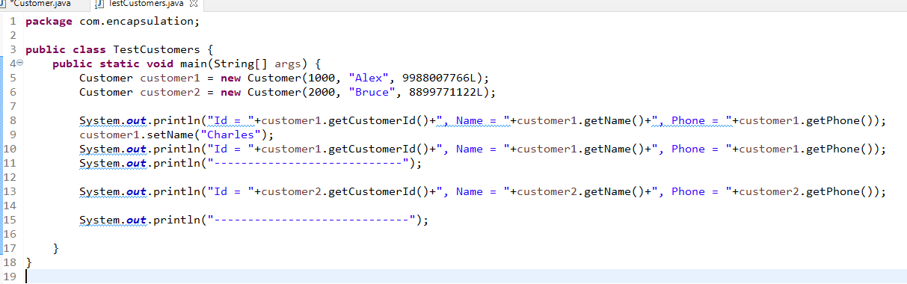

Output:

Id = 1000, Name = Alex, Phone = 9988007766

Id = 1000, Name = Charles, Phone = 9988007766

----------------------------

Id = 2000, Name = Bruce, Phone = 8899771122

-----------------------------

Short cut:

For Constructors: Right Click -> Source -> Generate constructor

For Getters & Setters: Right Click -> Source -> Generate setters & getters

Polymorphism:

An object with many forms, a single method which can perform multiple task

Ex: TV power button -> on/off

Polymorphism can be achieved in two ways

1. Method overloading (Compile time polymorphism) - at the compile time only you can find which method is called
2. Method overriding (Runtime polymorphism) - only at runtime you can find which method is called

Calcualator.java

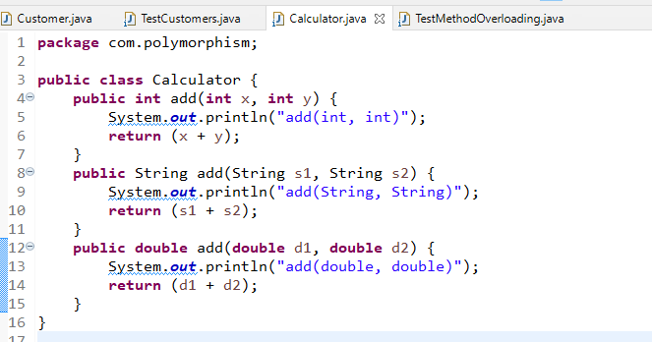

TestMethodOverloading.java

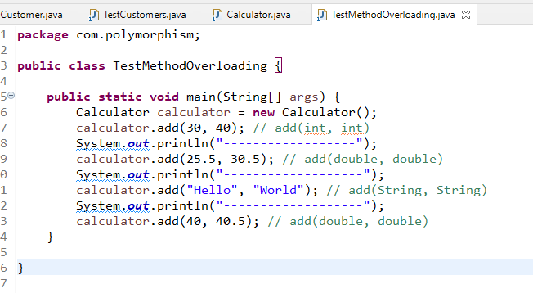

Runtime polymorphism

Here a method calling can be decided only when you know which object is calling it.

Person.java

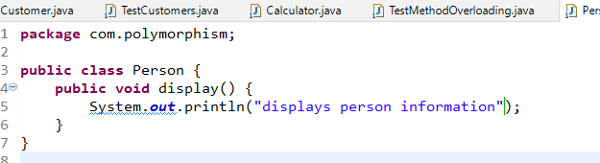

Student.java

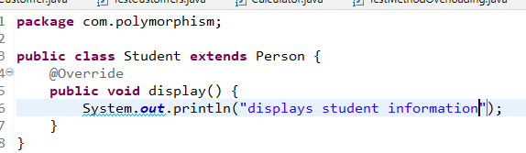

Employee.java

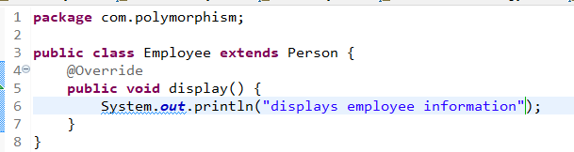

Customer.java

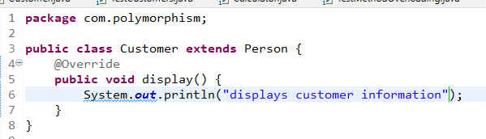

TestMethodOverriding.java

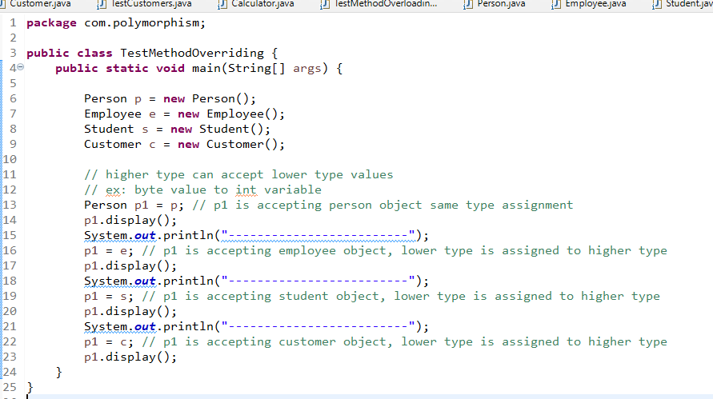

Output:

displays person information

-------------------------

displays employee information

-------------------------

displays student information

-------------------------

displays customer information

Abstraction:

Hiding the complexity and showing the necessary interface/details to the user, here the benefits you get would be the developers can concentrate on their code without understanding other’s code & also if any changes done in the implementation the caller’s code need not be modified.

Abstraction makes developers to call each other code without affecting their code.

Abstraction can be achieved in 2 ways

1. Interfaces - complete abstraction
2. Abstract classes - Partial abstrction

Interface: It will have only abstract methods, i.e., methods without logic & it will also have constants

Note: By default all the members of interfaces are public

Abstract class: It will have both abstract methods & complete methods, abstract class may not have full implementation.

Note: You can’t create object of interface & abstract class

Vehicle.java

**package** com.abstraction;

**public** **interface** Vehicle {

**void** mileage(); // by default methods are abstract

**abstract** **void** wheels(); // abstract is optional

}

TestAbstraction.java

**package** com.abstraction;

**abstract** **class** Bike **implements** Vehicle {

**public** **void** wheels() {

System.***out***.println("Bike has 2 wheels");

}

}

**class** Pulsar **extends** Bike {

**public** **void** mileage() {

System.***out***.println("Pulsar gives 40kmpl");

}

}

**class** RoyalEnfield **extends** Bike {

**public** **void** mileage() {

System.***out***.println("RoyalEnfield gives 30kmpl");

}

}

**public** **class** TestAbstraction {

**public** **static** **void** main(String[] args) {

Vehicle v;

Pulsar p = **new** Pulsar();

RoyalEnfield r = **new** RoyalEnfield();

v = p;

v.mileage(); // pulsar mileage

v.wheels(); // pulsar wheels

v = r;

v.mileage(); // royal enfield mileage

v.wheels(); // royal enfield wheels

}

}